# Hướng dẫn cài đặt và cấu hình

**Percona XtraDB Cluster 8.0**

# Chuẩn bị trước khi cài đặt.

# Download Percona-XtraDB-Cluster-8.0.18-r167-el7-x86_64-bundle.tar :

# <https://www.percona.com/downloads/Percona-XtraDB-Cluster-80/LATEST/>

# Download Percona-XtraBackup-8.0-11-r486c270-el7-x86_64-bundle.tar

# <https://www.percona.com/downloads/XtraBackup/>

# Download Percona GPG

# Key: <https://www.percona.com/downloads/RPM-GPG-KEY-percona>

# Mở port trong iptables 3306, 4444, 4567 and 4568 , disabled selinux.

# Dùng lệnh : # vi /etc/sysconfig/iptables

# Sau đó thêm đoạn sau :

# ########### Connect DB ##############################

# -A OUTPUT -m state --state NEW -d 192.168.0.0/24 -m tcp -p tcp --dport 3306 -j ACCEPT

# -A INPUT -m state --state NEW -s 192.168.0.0/24 -m tcp -p tcp --dport 3306 -j ACCEPT

1. **Cài đặt**

rpm -ivh perl-Digest-1.17-245.el7.noarch.rpm

rpm -ivh perl-Digest-MD5-2.52-3.el7.x86_64.rpm

rpm -ivh perl-DBD-MySQL-4.023-6.el7.x86_64.rpm

rpm -ivh libev-4.15-7.el7.x86_64.rpm

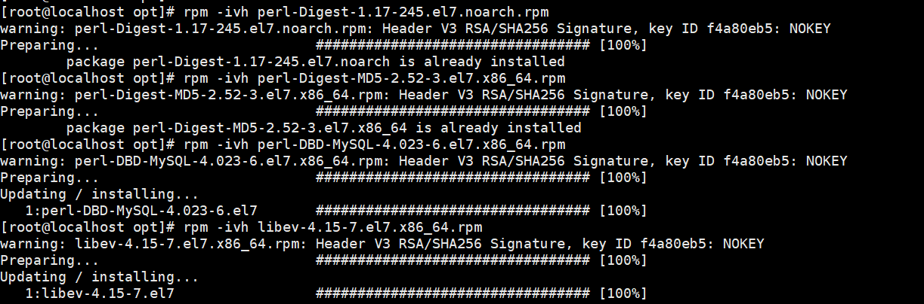

rpm -ivh percona-xtrabackup-80-8.0.11-1.el7.x86_64.rpm

rpm -ivh percona-xtrabackup-80-debuginfo-8.0.11-1.el7.x86_64.rpm

rpm -ivh percona-xtrabackup-test-80-8.0.11-1.el7.x86_64.rpm

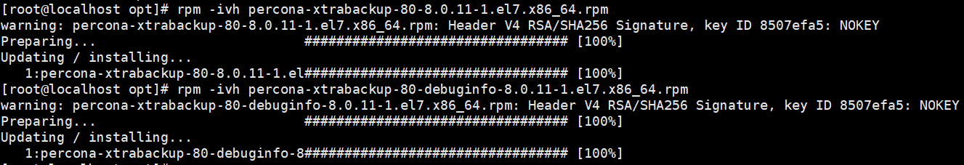

**Remove mariadb-libs có sẵn trên CentOS 7**

rpm -e mariadb-libs-5.5.52-1.el7.x86_64 –nodeps

rpm -ivh percona-xtradb-cluster-client-8.0.18-9.3.el7.x86_64.rpm

rpm -ivh percona-xtradb-cluster-shared-8.0.18-9.3.el7.x86_64.rpm

rpm -ivh percona-xtradb-cluster-shared-compat-8.0.18-9.3.el7.x86_64.rpm

rpm -ivh percona-xtradb-cluster-garbd-8.0.18-9.3.el7.x86_64.rpm

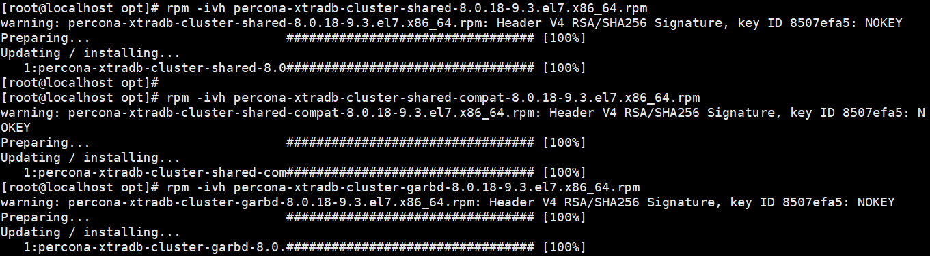

Để cài được percona-xtradb-cluster-devel-8.0.18-9.3.el7.x86_64.rpm cần cài đặt pkgconfig(openssl). Cần cài đặt openssl-devel và pkgconfig:

rpm -Uvh libsepol-2.5-10.el7.x86_64.rpm

rpm -Uvh pcre-8.32-17.el7.x86_64.rpm

rpm -ivh keyutils-libs-devel-1.5.8-3.el7.x86_64.rpm

rpm -Uvh krb5-libs-1.15.1-46.el7.x86_64.rpm

rpm -ivh libkadm5-1.15.1-46.el7.x86_64.rpm

rpm -ivh pcre-devel-8.32-17.el7.x86_64.rpm

rpm -ivh libsepol-devel-2.5-10.el7.x86_64.rpm

rpm -ivh libverto-devel-0.2.5-4.el7.x86_64.rpm

rpm -ivh keyutils-libs-devel-1.5.8-3.el7.x86_64.rpm

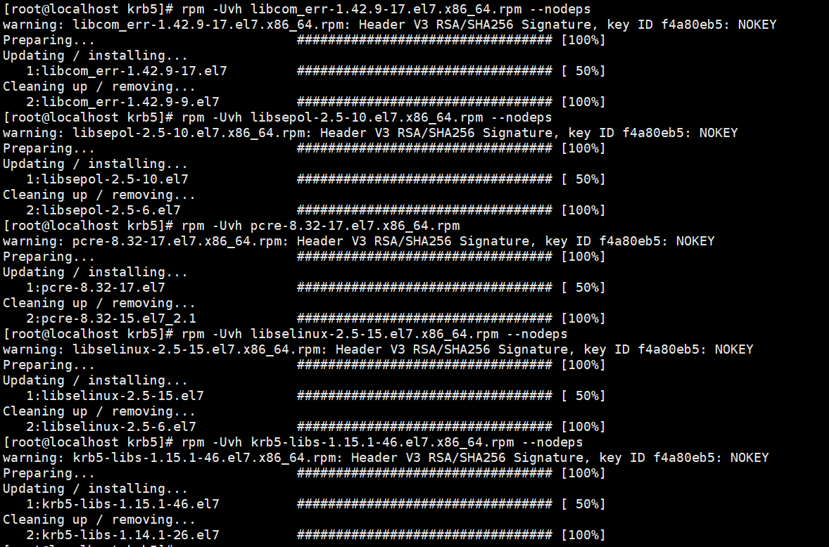

**Cài đặt krb5-devel**

rpm -Uvh libselinux-2.5-15.el7.x86_64.rpm --nodeps

rpm -Uvh libselinux-utils-2.5-15.el7.x86_64.rpm --nodeps

rpm -Uvh libselinux-python-2.5-15.el7.x86_64.rpm --nodeps

rpm -Uvh libcom_err-devel-1.42.9-17.el7.x86_64.rpm --nodeps

rpm -ivh libselinux-devel-2.5-15.el7.x86_64.rpm

rpm -ivh krb5-devel-1.15.1-46.el7.x86_64.rpm

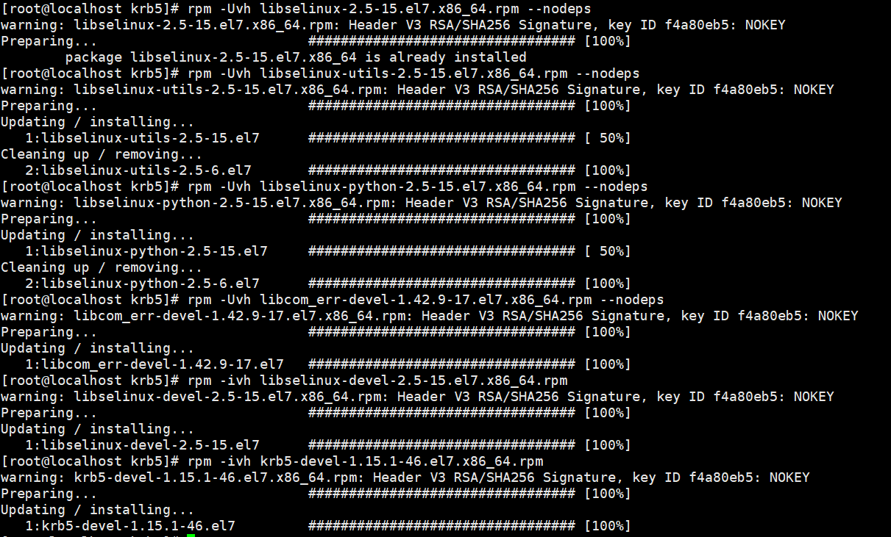

**Cài đặt openssl-devel**

rpm -Uvh zlib-1.2.7-18.el7.x86_64.rpm

rpm -Uvh openssl-libs-1.0.2k-19.el7.x86_64.rpm --nodeps

rpm -ivh zlib-devel-1.2.7-18.el7.x86_64.rpm

rpm -ivh openssl-devel-1.0.2k-19.el7.x86_64.rpm

rpm -Uvh openssl-1.0.2k-19.el7.x86_64.rpm

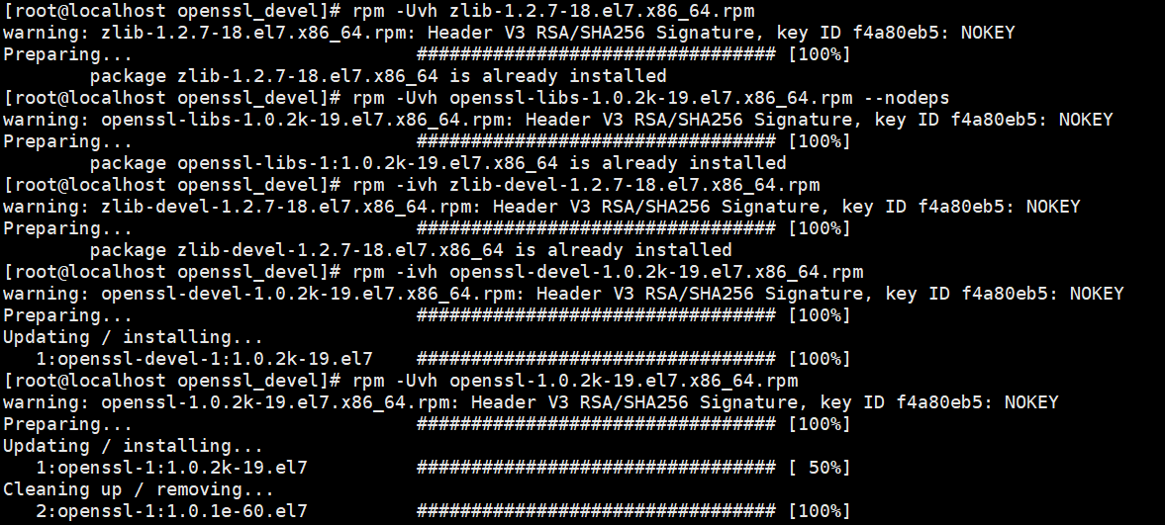

rpm -ivh percona-xtradb-cluster-devel-8.0.18-9.3.el7.x86_64.rpm

rpm -ivh percona-xtradb-cluster-debuginfo-8.0.18-9.3.el7.x86_64.rpm

rpm -ivh qpress-11-1.el7.x86_64.rpm

rpm -ivh socat-1.7.3.2-2.el7.x86_64.rpm

rpm -ivh percona-xtradb-cluster-server-8.0.18-9.3.el7.x86_64.rpm

rpm -ivh percona-xtradb-cluster-8.0.18-9.3.el7.x86_64.rpm

**Để cài được percona-xtradb-cluster-test-8.0.18-9.3.el7.x86_64 cần cài đặt perl-Test-Simple:**

rpm -ivh perl-Env-1.04-2.el7.noarch.rpm

rpm -ivh perl-Test-Harness-3.28-3.el7.noarch.rpm

rpm -ivh perl-Test-Simple-0.98-243.el7.noarch.rpm

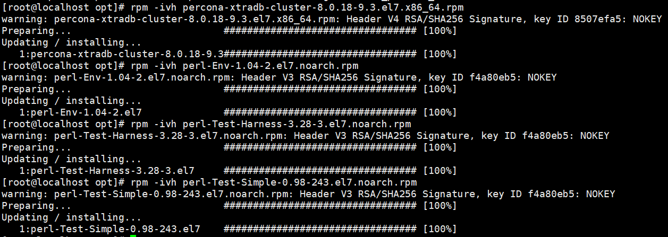

rpm -ivh percona-xtradb-cluster-test-8.0.18-9.3.el7.x86_64.rpm

rpm -ivh percona-xtradb-cluster-full-8.0.18-9.3.el7.x86_64.rpm